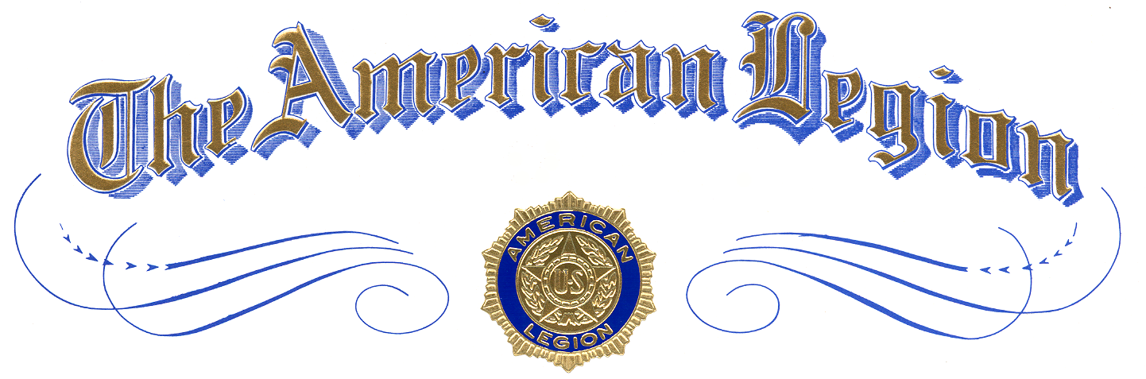

Winner of

District XX Oratorical

Winner Name
of
School Name

is awarded this certificate of Achievement
and a $0,000 Scholarship
in

The American Legion
National High School Oratorical Contest

Presented by
Commander, The American Legion District XX
at Location, Texas
Month Day, Year

Attest:

